**Implementation of End To End Kaggle Machine Learning Project With Deployment**

Create environment

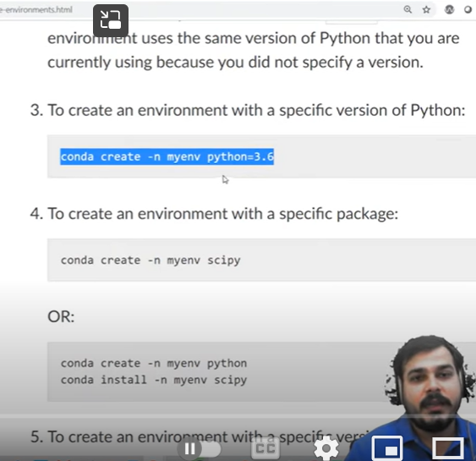

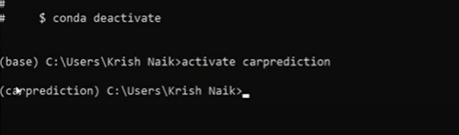

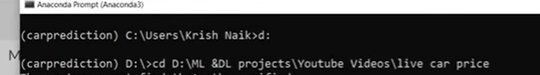

Cd working location path where ur files



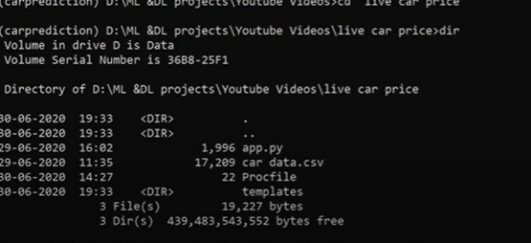

Start jupyter notebook



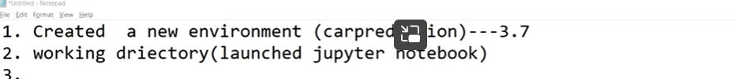

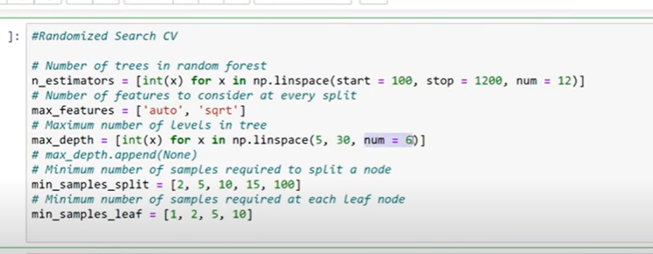

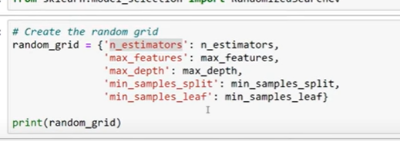

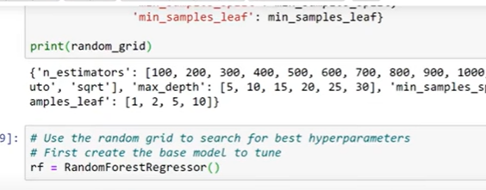

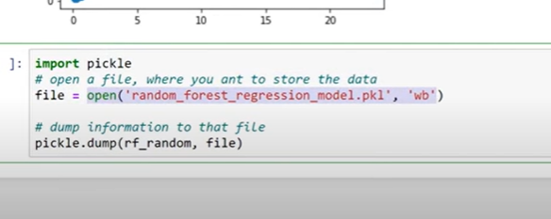

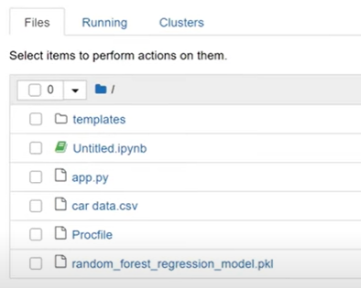

Now create requirement.txt



Go to that location

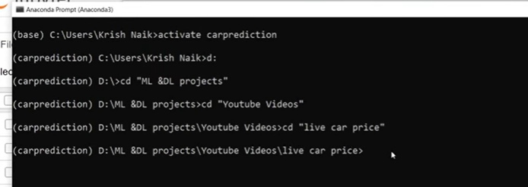



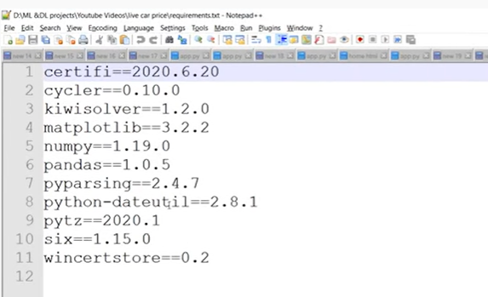

Go to same location

Open spider

Go to anaconda

Go to specific environment

Install flask

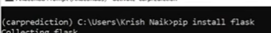



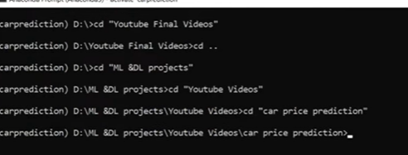



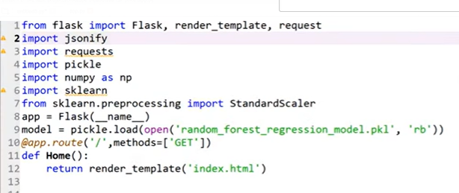

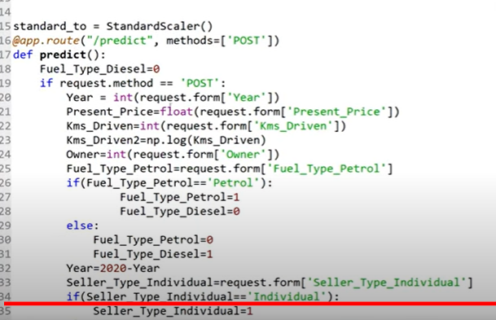

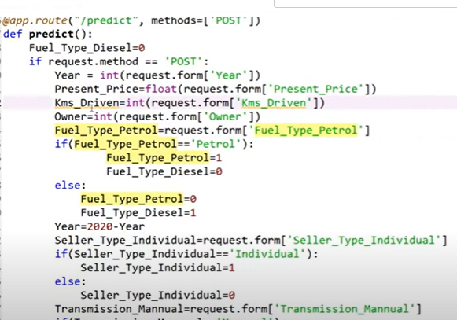

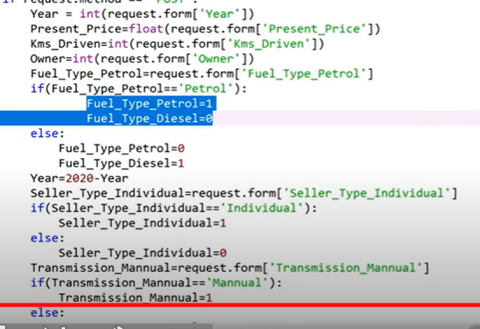

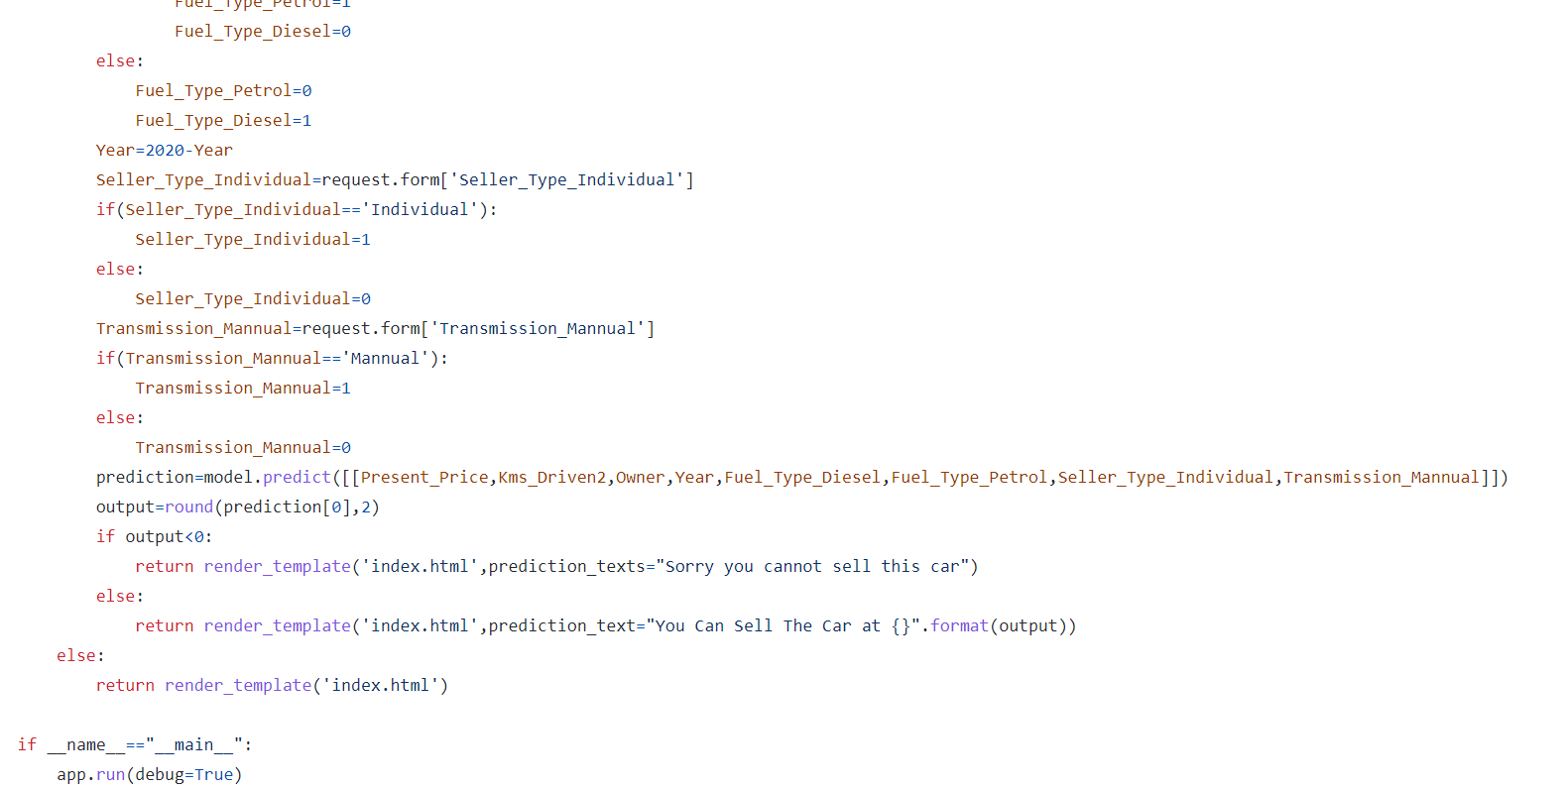

|  |
| --- |
| <!DOCTYPE html> |
|  | <html lang="en"> |
|  |  |
|  | <head> |
|  | <meta charset="UTF-8"> |
|  | <meta name="viewport" content="width=device-width, initial-scale=1.0"> |
|  | <title>Document</title> |
|  | </head> |
|  |  |
|  | <body> |
|  |  |
|  | <div style="color:blue"> |
|  | <form action="{{ url_for('predict')}}" method="post"> |
|  | <h2>Predictive analysis</h2> |
|  | <h3>Year</h3> |
|  | <input id="first" name="Year" type="number "> |
|  | <h3>What is the Showroom Price?(In lakhs)</h3><br><input id="second" name="Present_Price" required="required"> |
|  | <h3>How Many Kilometers Drived?</h3><input id="third" name="Kms_Driven" required="required"> |
|  | <h3>How much owners previously had the car(0 or 1 or 3) ?</h3><br><input id="fourth" name="Owner" required="required"> |
|  | <h3>What Is the Fuel type?</h3><br><select name="Fuel_Type_Petrol" id="fuel" required="required"> |
|  | <option value="Petrol">Petrol</option> |
|  | <option value="Diesel">Diesel</option> |
|  | <option value="Diesel">CNG</option> |
|  | </select> |
|  | <h3>Are you A Dealer or Individual</h3><br><select name="Seller_Type_Individual" id="resea" required="required"> |
|  | <option value="Dealer">Dealer</option> |
|  | <option value="Individual">Individual</option> |
|  | </select> |
|  | <h3>Transmission type</h3><br><select name="Transmission_Mannual" id="research" required="required"> |
|  | <option value="Mannual">Manual Car</option> |
|  | <option value="Automatic">Automatic Car</option> |
|  | </select> |
|  | <br><br><button id="sub" type="submit ">Calculate the Selling Price</button> |
|  | <br> |
|  |  |
|  |  |
|  |  |
|  |  |
|  | </form> |
|  |  |
|  |  |
|  |  |
|  | <br><br><h3>{{ prediction_text }}<h3> |
|  | </div> |
|  |  |
|  |  |
|  |  |
|  |  |
|  | <style> |
|  | body { |
|  | background-color: lightslategray; |
|  | text-align: center; |
|  | padding: 0px; |
|  | } |
|  |  |
|  | #research { |
|  | font-size: 18px; |
|  | width: 100px; |
|  | height: 23px; |
|  | top: 23px; |
|  | } |
|  |  |
|  | #box { |
|  | border-radius: 60px; |
|  | border-color: 45px; |
|  | border-style: solid; |
|  | font-family: cursive; |
|  | text-align: center; |
|  | background-color: rgb(168, 131, 61); |
|  | font-size: medium; |
|  | position: absolute; |
|  | width: 700px; |
|  | bottom: 9%; |
|  | height: 850px; |
|  | right: 30%; |
|  | padding: 0px; |
|  | margin: 0px; |
|  | font-size: 14px; |
|  | } |
|  |  |
|  | #fuel { |
|  | width: 83px; |
|  | height: 43px; |
|  | text-align: center; |
|  | border-radius: 14px; |
|  | font-size: 20px; |
|  | } |
|  |  |
|  | #fuel:hover { |
|  | background-color: coral; |
|  | } |
|  |  |
|  | #research { |
|  | width: 99px; |
|  | height: 43px; |
|  | text-align: center; |
|  | border-radius: 14px; |
|  | font-size: 18px; |
|  | } |
|  |  |
|  | #research:hover { |
|  | background-color: coral; |
|  | } |
|  |  |
|  | #resea { |
|  | width: 99px; |
|  | height: 43px; |
|  | text-align: center; |
|  | border-radius: 14px; |
|  | font-size: 18px; |
|  | } |
|  |  |
|  | #resea:hover { |
|  | background-color: coral; |
|  | } |
|  |  |
|  | #sub { |
|  | width: 120px; |
|  | height: 43px; |
|  | text-align: center; |
|  | border-radius: 14px; |
|  | font-size: 18px; |
|  | } |
|  |  |
|  | #sub:hover { |
|  | background-color: darkcyan; |
|  | } |
|  |  |
|  | #first { |
|  | border-radius: 14px; |
|  | height: 25px; |
|  | font-size: 20px; |
|  | text-align: center; |
|  | } |
|  |  |
|  | #second { |
|  | border-radius: 14px; |
|  | height: 25px; |
|  | font-size: 20px; |
|  | text-align: center; |
|  | } |
|  |  |
|  | #third { |
|  | border-radius: 14px; |
|  | height: 25px; |
|  | font-size: 20px; |
|  | text-align: center; |
|  | } |
|  |  |
|  | #fourth { |
|  | border-radius: 14px; |
|  | height: 25px; |
|  | font-size: 20px; |
|  | text-align: center; |
|  | } |
|  | </style> |
|  | </body> |
|  |  |
|  | </html> |

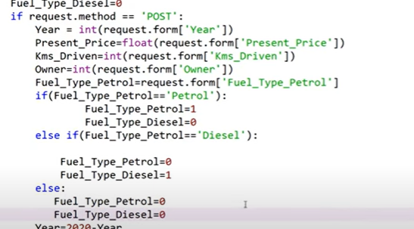

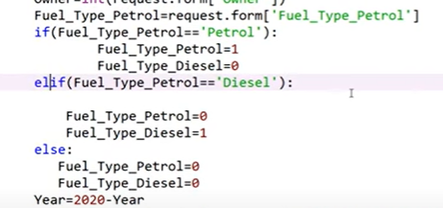

Now diployementt

Heroku

**Movie Recommender System Project | Content Based Recommender System with Heroku Deployment**

**Types of movies**

Content based

Collaborative filtering based

Hybrid based

Content based : romantic , thriller(based on similarity of content)

Collaborative filtering : user interest ( behavir of 2 users, they watch same type of movies and give same rating )

Hybrid: combination of two models like content and collaborative

**Movie Recommender System Project | Content Based Recommender System with Heroku Deployment**

*# Input data files are available in the read-only "../input/" directory*

*# For example, running this (by clicking run or pressing Shift+Enter) will list all files under the input directory*

**import** os

**for** dirname, _, filenames **in** os**.**walk('/kaggle/input'):

**for** filename **in** filenames:

print(os**.**path**.**join(dirname, filename))

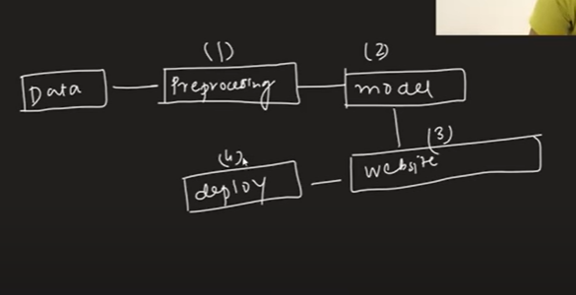

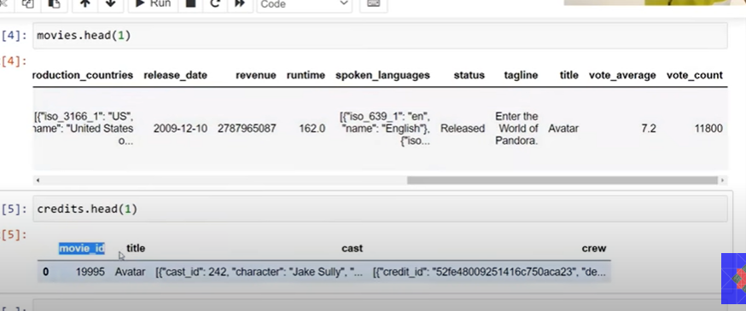

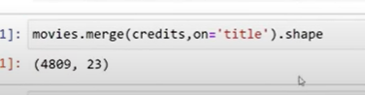

Imp columns

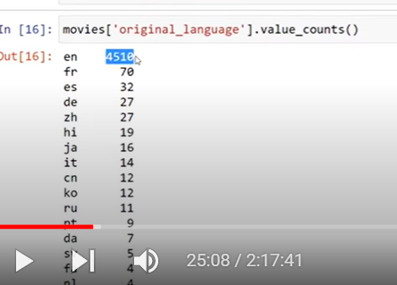

99 percentage is english’

Remaining other language – this is not required

Title and original title

Keep title leave original title

* Keep over view of movie”
* Popularity could be imp- but not using
* Production companies
* 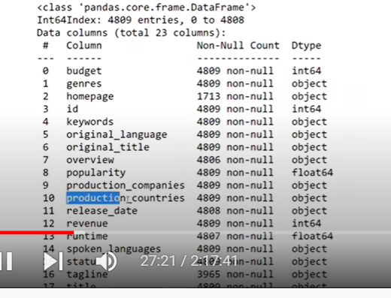
* 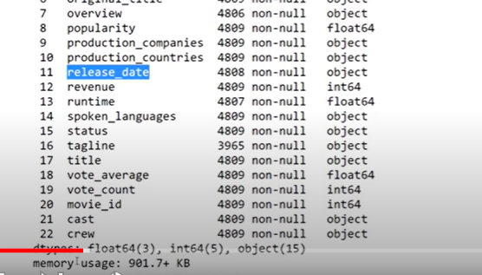
* 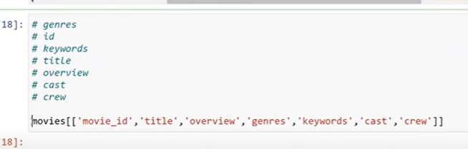
* 

Merging some columns and prepare : tags

Cast : only top 3

Crew : director

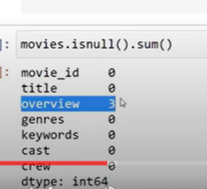

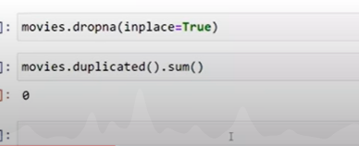

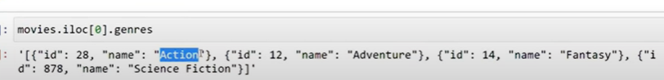

Need to make genres like below

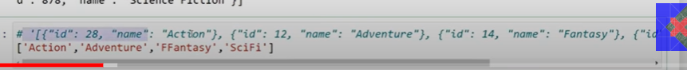

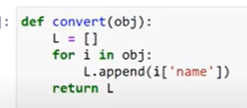

Actually the above list is in string state

We must make it as list

Below function will chge string of list to list

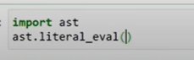

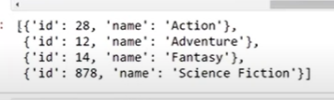

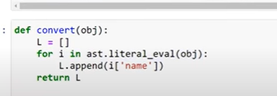

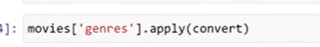

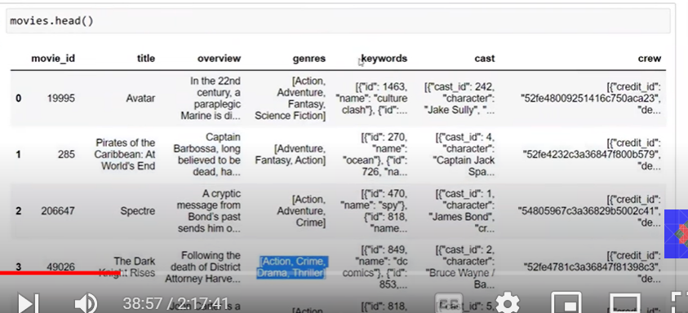

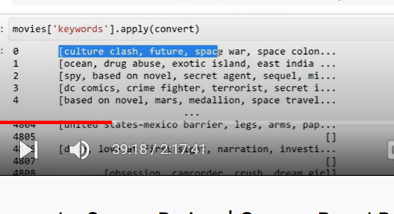



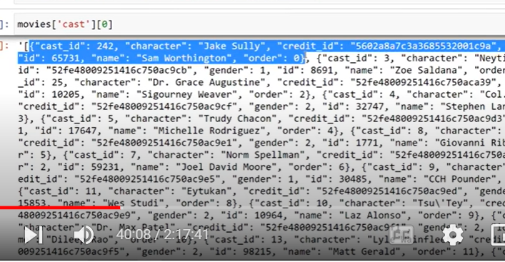

We need only 3 names

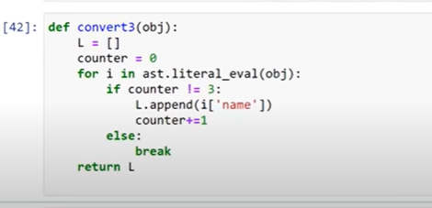

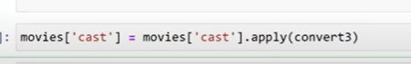

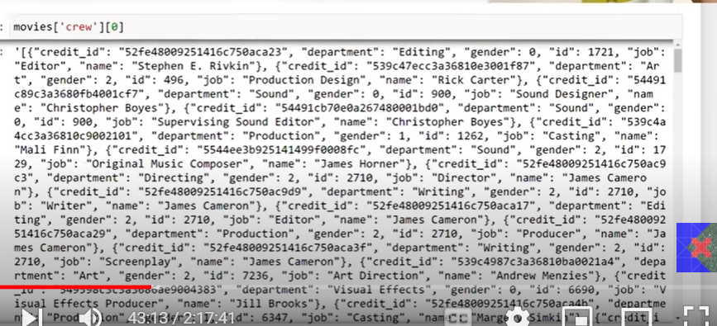

In movies job= director that dictionary we need

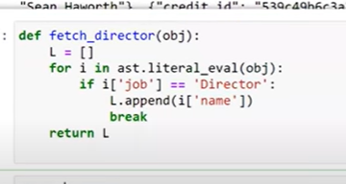

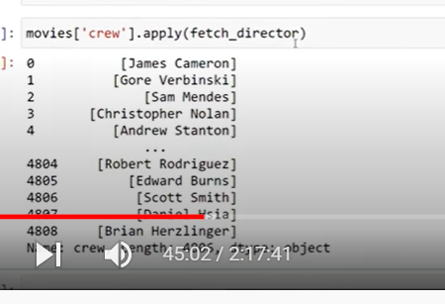

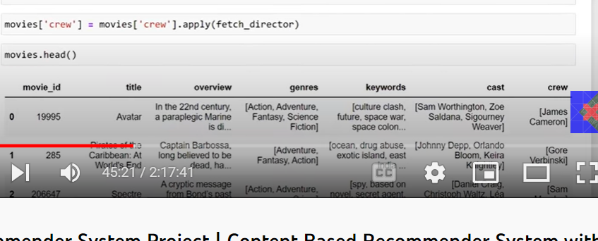

Now over view column is string – we must create as string

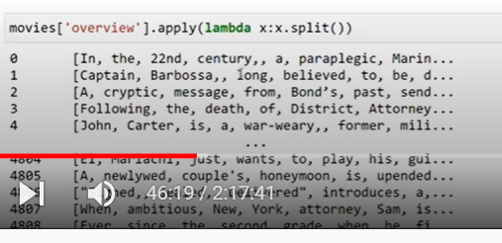



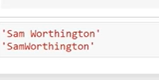

“ sam Worthington” : same name

Model gets confused if space is there between words if other person name also with same same word

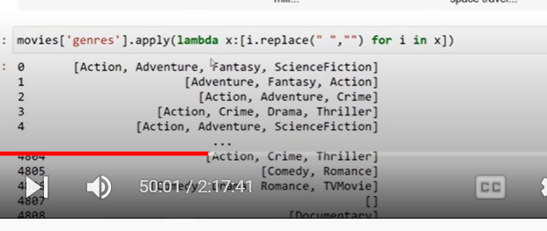

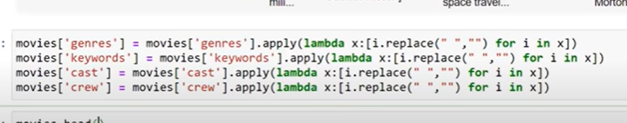

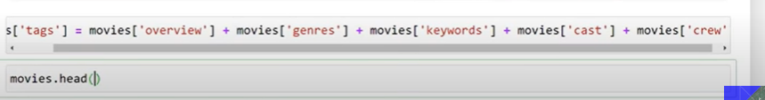

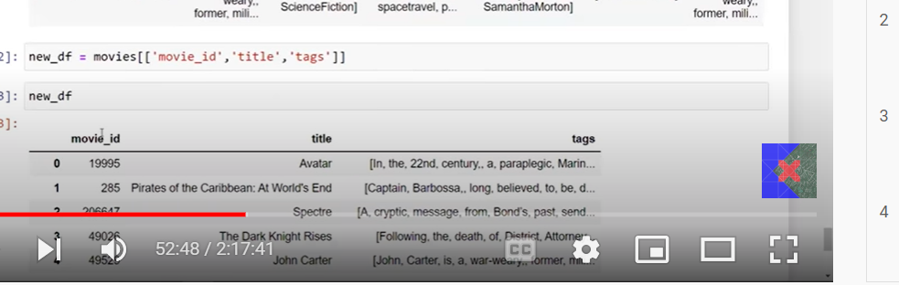

We need to convert list to string on tag



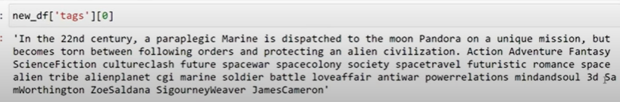

Lower case

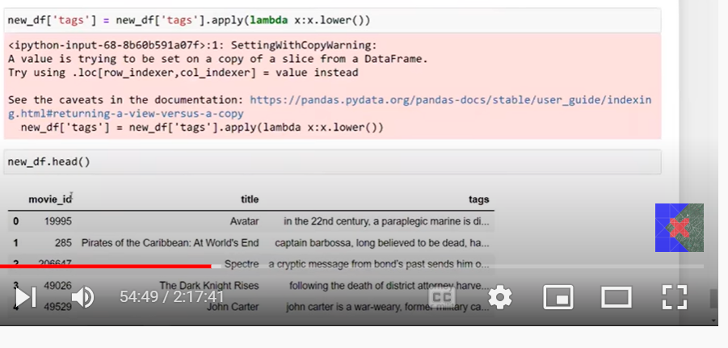

Now text vectorization

Each movie tag must be created to a vector

Each movie as vector

If 5000 movies are there 5000 vector

We take closest vectors

Text vectorization

We use: bag of words

Take top 5000 words in all sentences

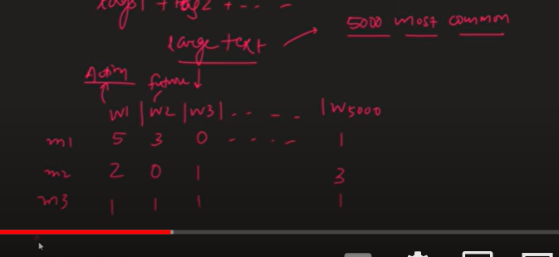

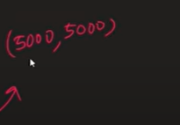

5000 words* 5000 movies

5000 dimensional space

Before vectorization remove stop words

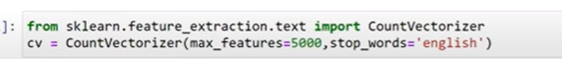

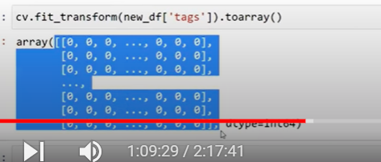

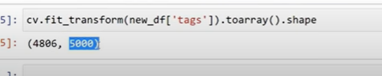



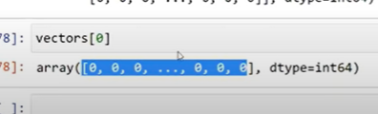

Generally we get sparse metrix

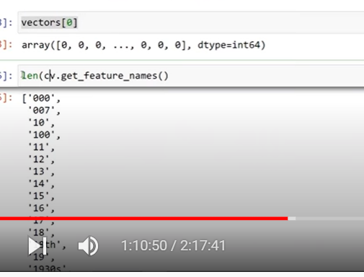

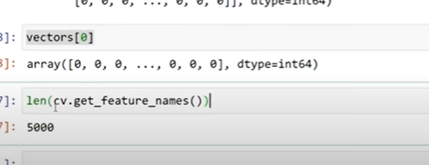

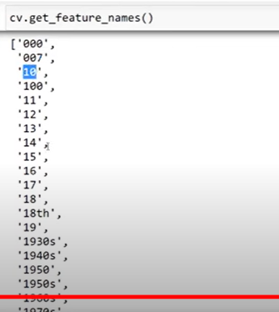

Now do stemming

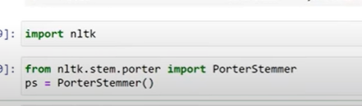

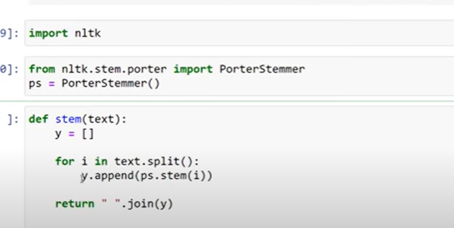

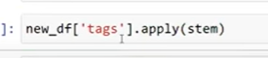

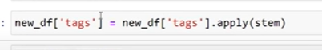

Now repeat all steps

From countvectorize





5000 words* 5000 movies

5000 dimensional space

Before vectorization remove stop words











Generally we get sparse metrix







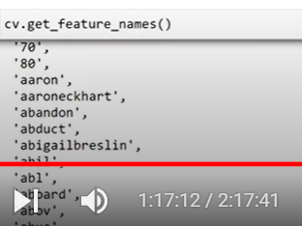

How many ever movies that many movies

5000 words: 5000 dimentions

now we need to calculate distance between one movie to other in 5000 dimentional space

less distance similar type of movie

now we find cosin similarity

not Euclidean

in eucleadian distance we find distance between one tip to other

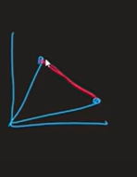

But we calculate angle between them

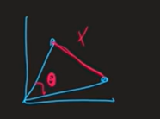

When we are working with high dimentional : Euclidean distance will fail

So we use Cosine similarity

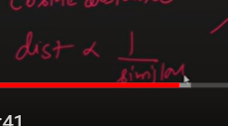

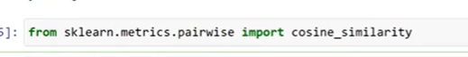

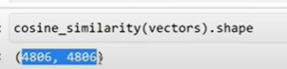

4808 movies distances with 4808 movies

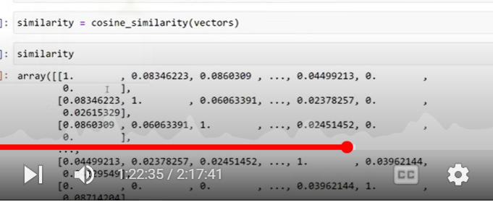

It’s a array of array

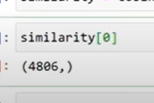

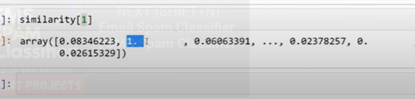

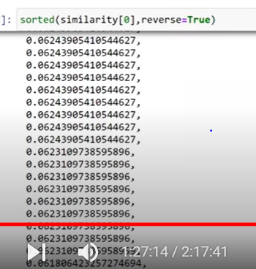

When we are reading we may loose index position

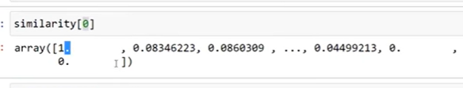

For this we use enumerate

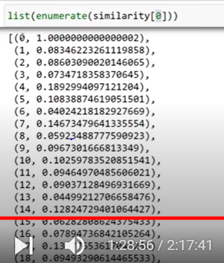

0 th movie with zero movie similarity

Now apply sort

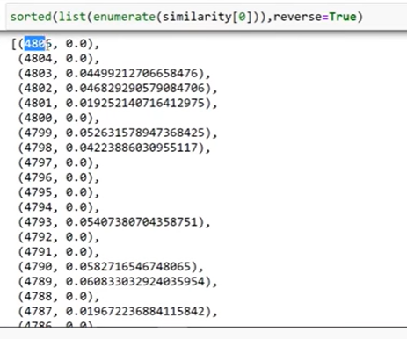

Sorted on index

But we need on similarity

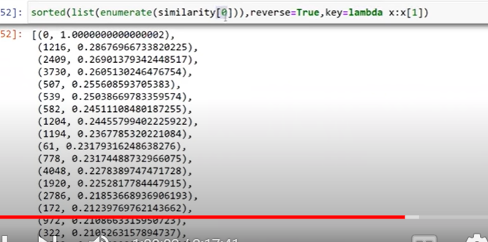

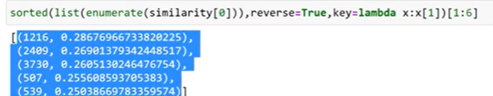

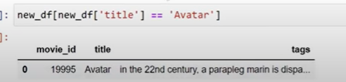

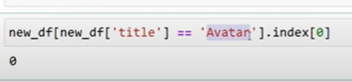

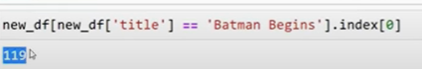

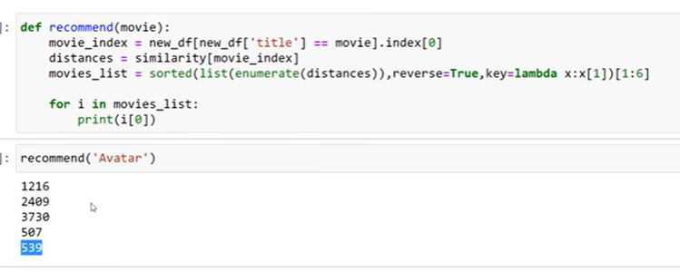

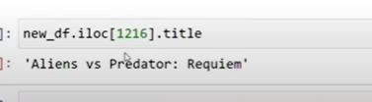

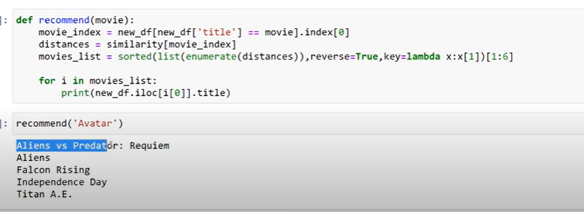

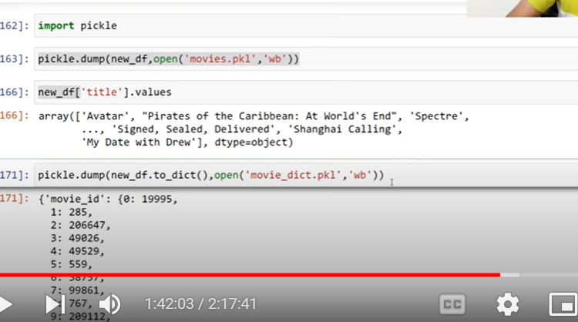

Create website

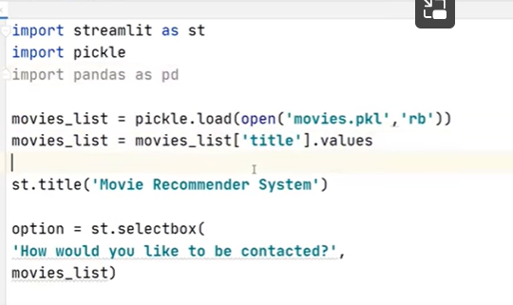

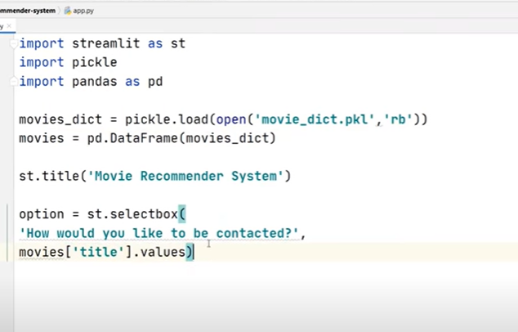

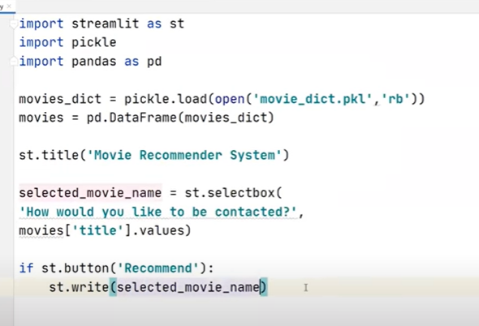

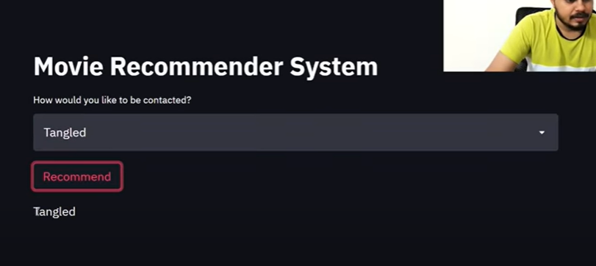

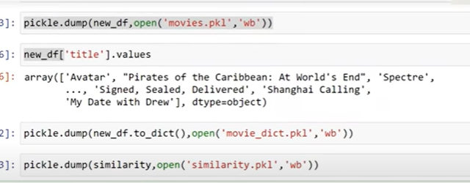

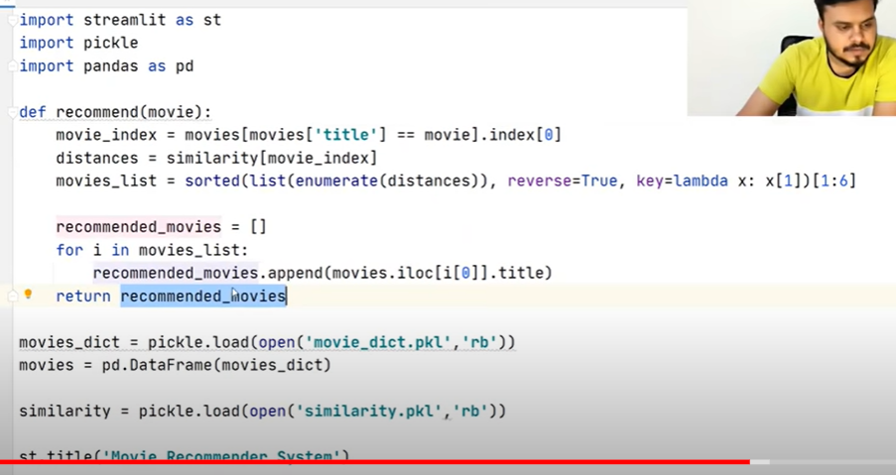

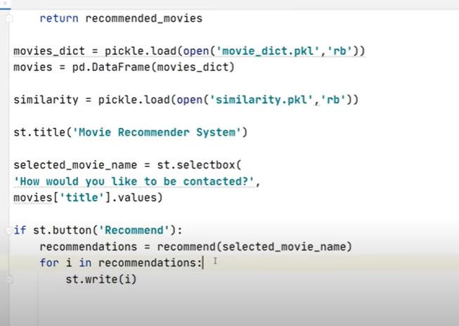

**Car Price Predictor Project | Machine Learning | Linear Regression**

[car_price_predictor/Quikr Analysis.ipynb at master · rajtilakls2510/car_price_predictor · GitHub](https://github.com/rajtilakls2510/car_price_predictor/blob/master/Quikr%20Analysis.ipynb)

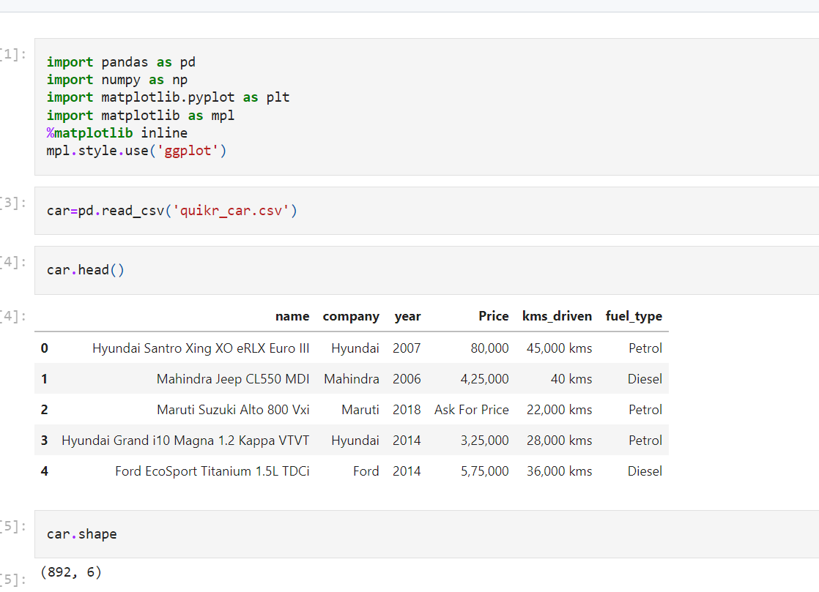

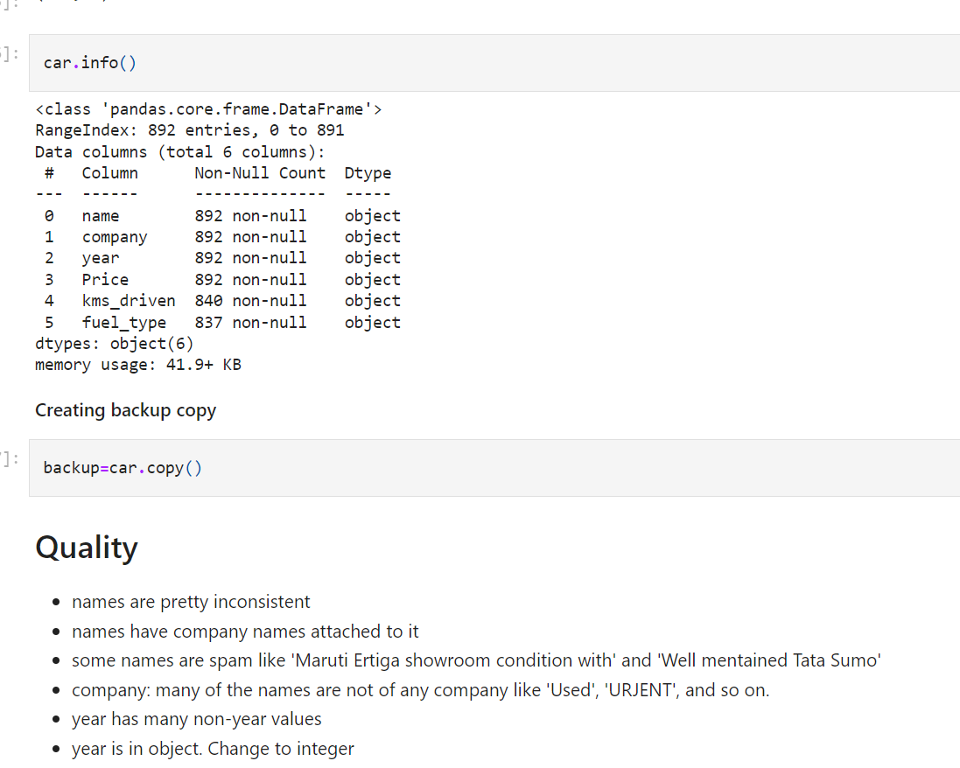

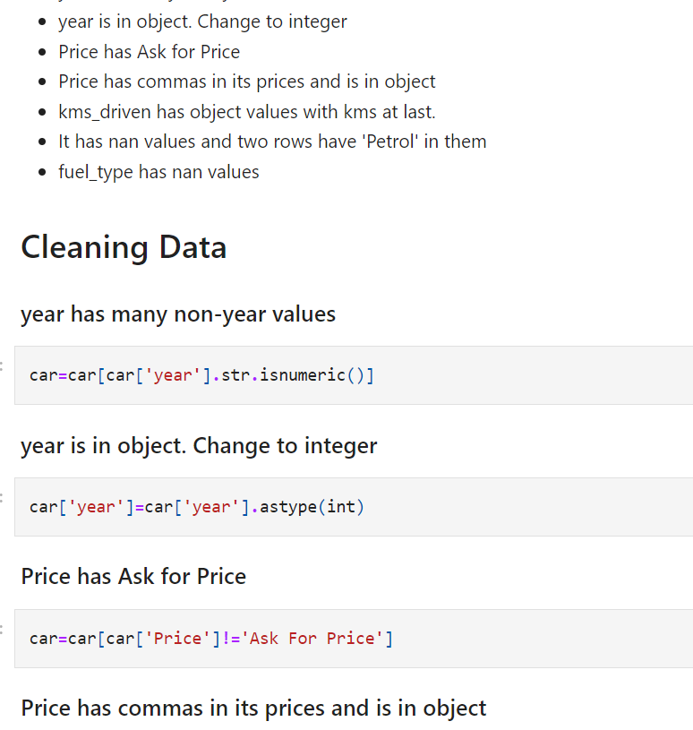

Car year has some string values

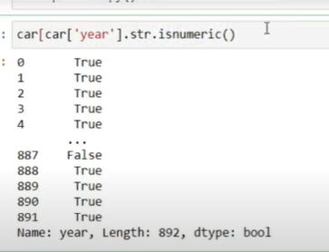

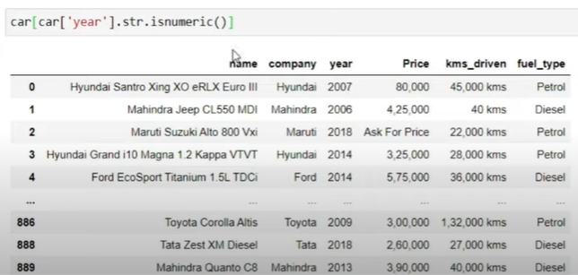

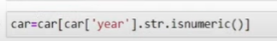

Year is obj to int

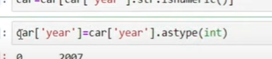

Price column has

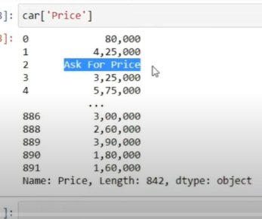

Remove it

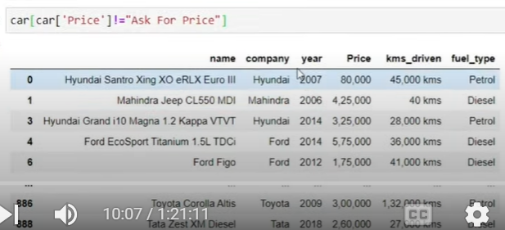

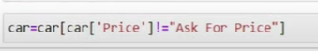

Price has , and obj

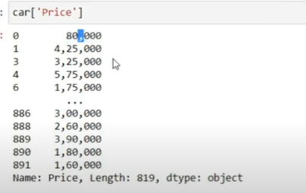

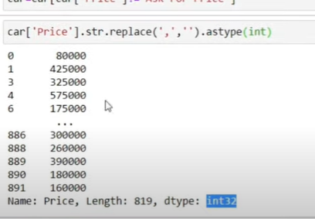



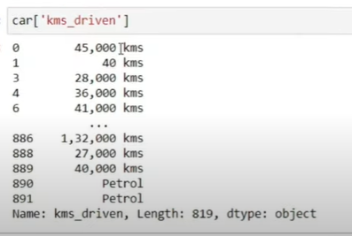

Km attached with num

Split using space

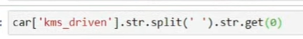

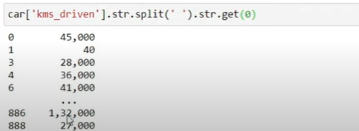

Now replace , with empty string

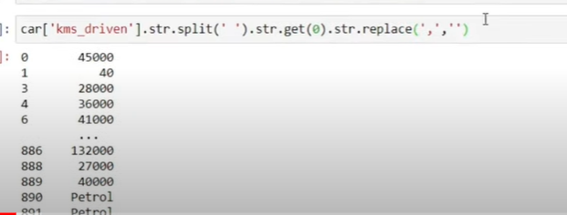



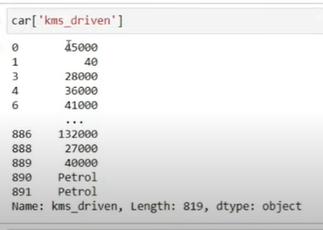

It has petrol value

Remove it

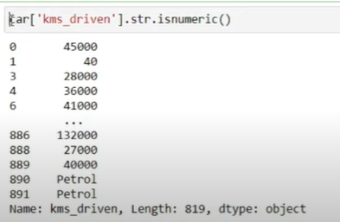

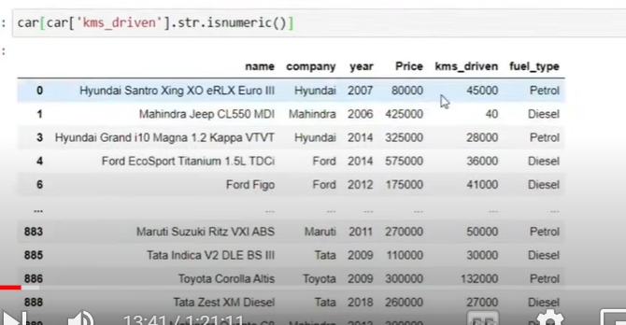

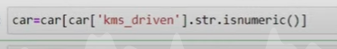

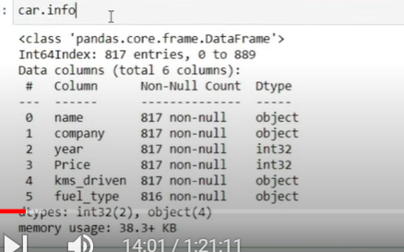

Km_driven is object we need to convert to int



Fuel type has nan

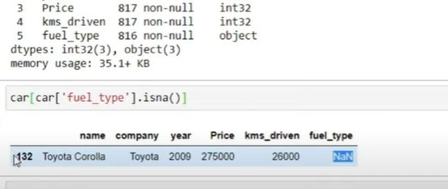

Excluding that

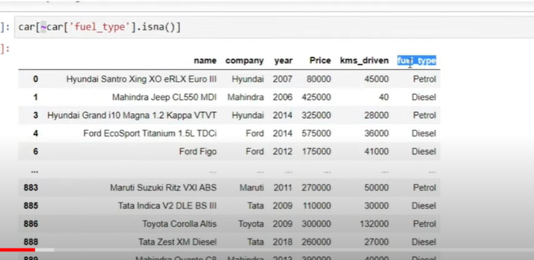

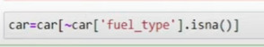

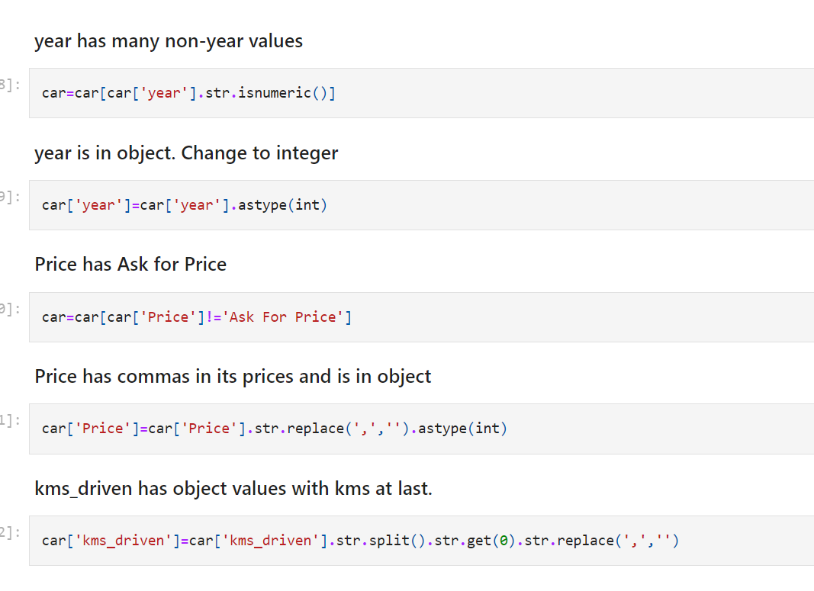

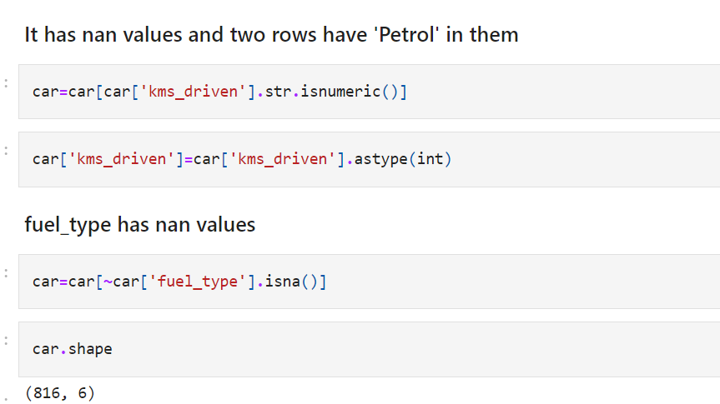

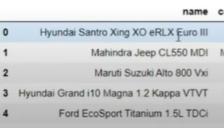

Name is big

We need to keep 1st 3 words which are needed

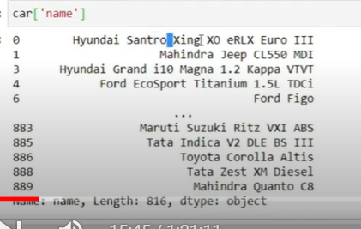

Split at space

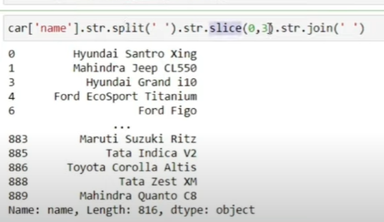

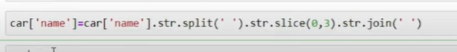

Now see dataframe

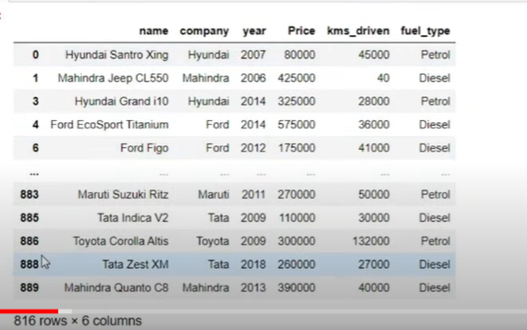

Indices not in order

Reset index

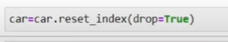

Drop = true means removing old index

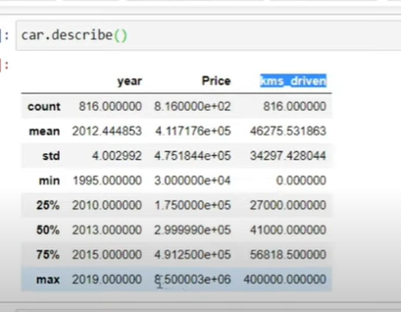

Find outer lier since 75th percentile and max has big difference

So find cars greater tha 60 lakh

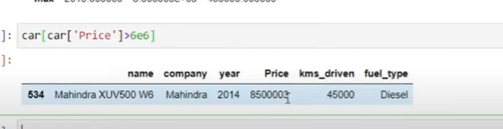

Only one car --- 80 lakh – outlier

Remove that

So we are keeping cars less than

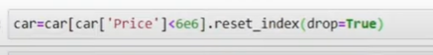

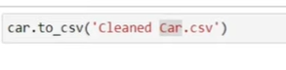

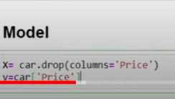

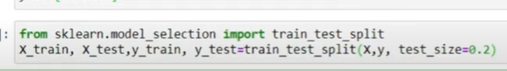

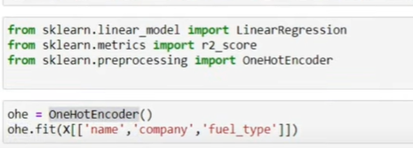

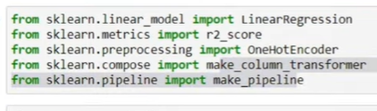

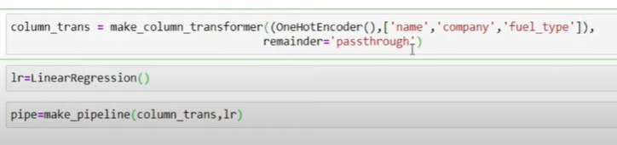

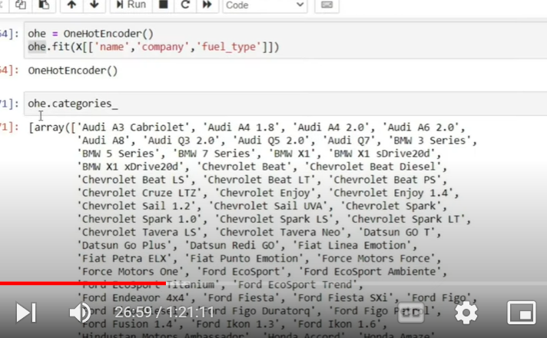

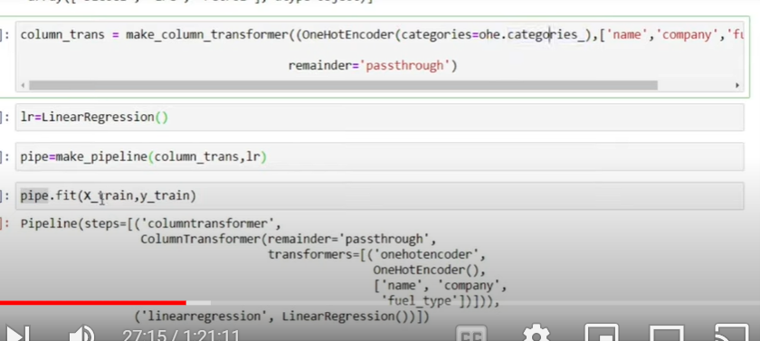

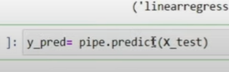

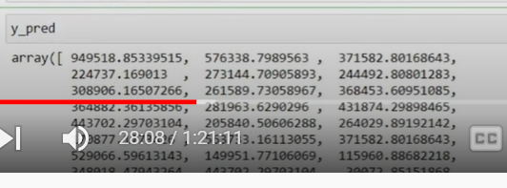

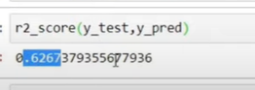

Data is very less

Different change in split

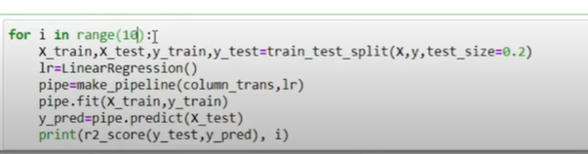

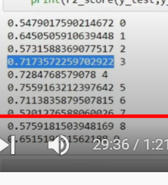

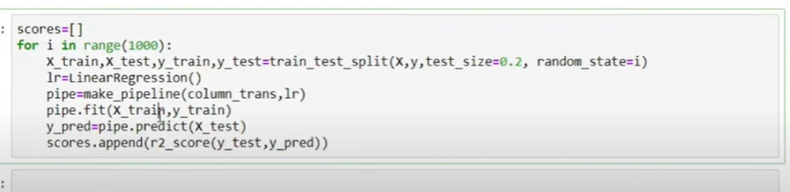

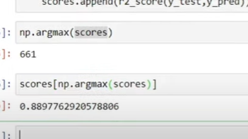

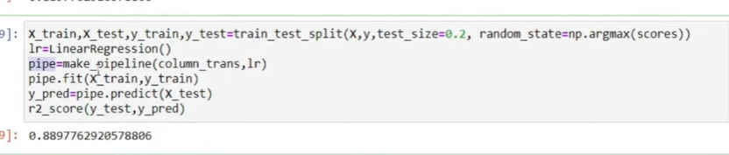

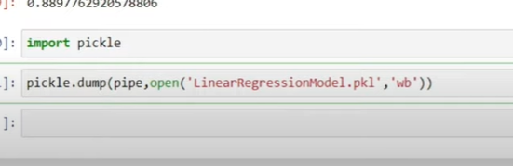



**Bangalore House Price Prediction | Regression Project | End to End Machine Learning Projects**

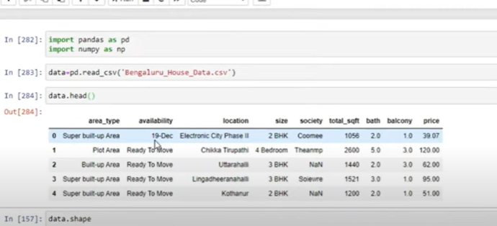

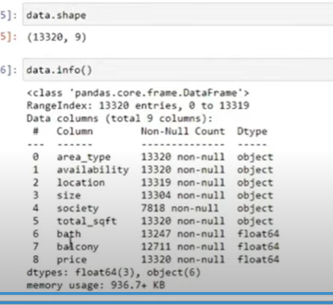

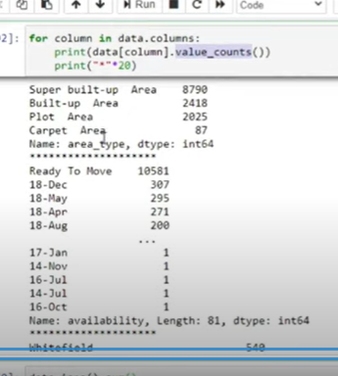

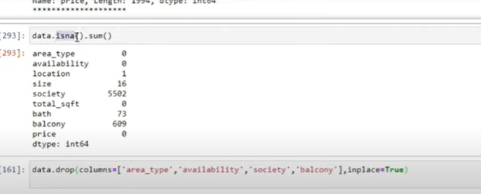

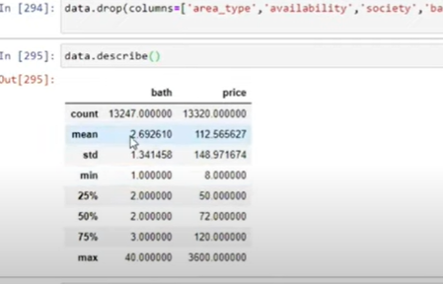

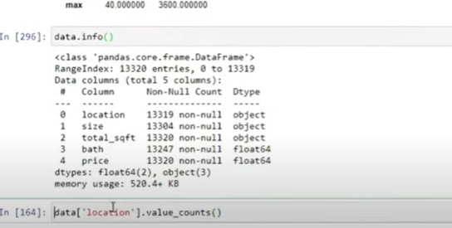

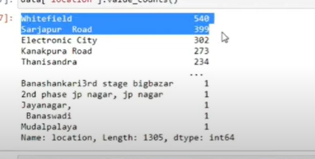

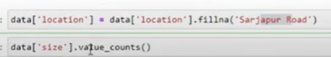

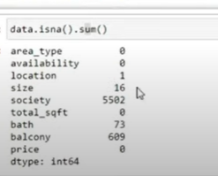

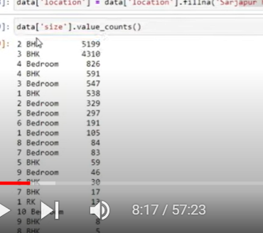

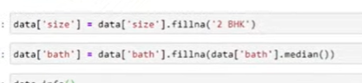

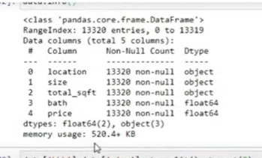

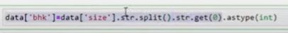

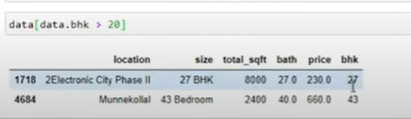

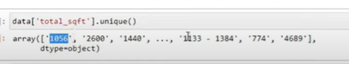

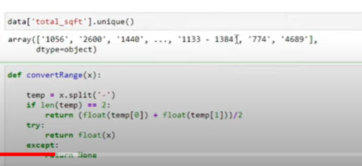

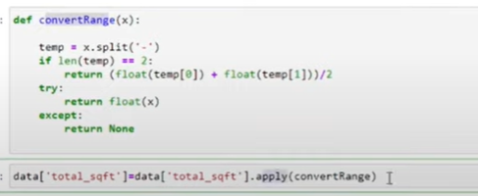

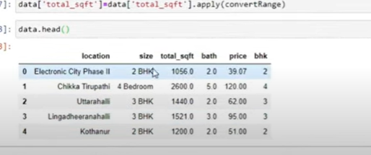

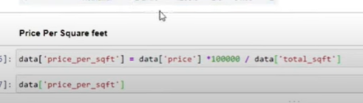

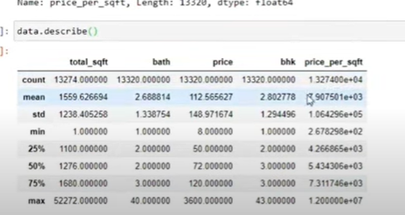

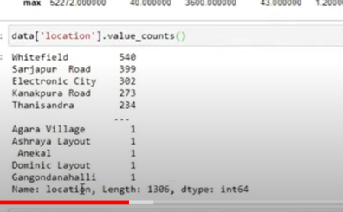

Very difficult to do ohe

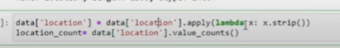

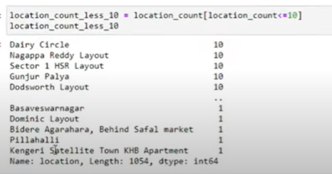



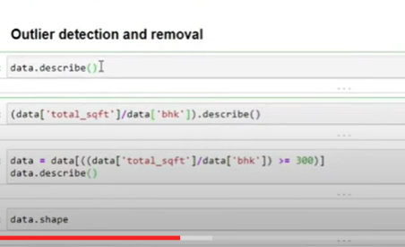

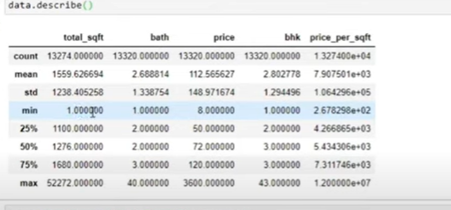

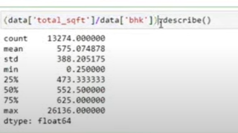

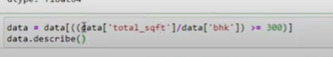

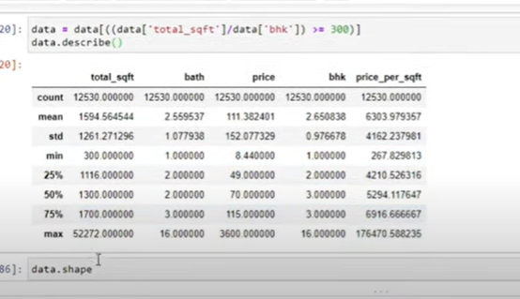

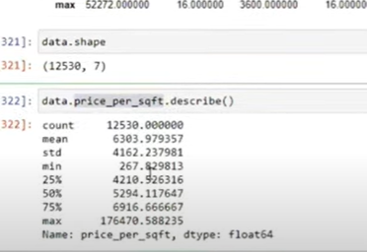

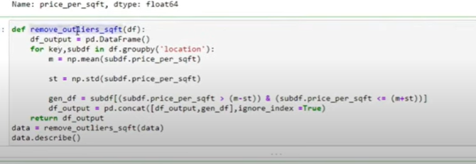

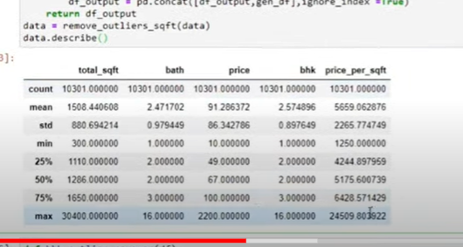

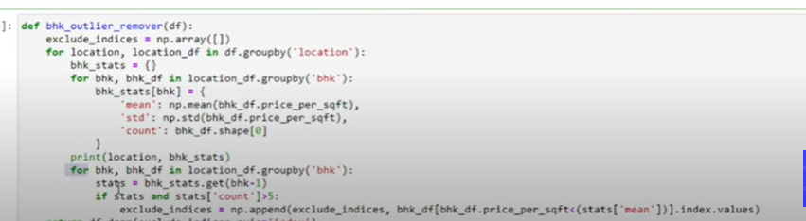

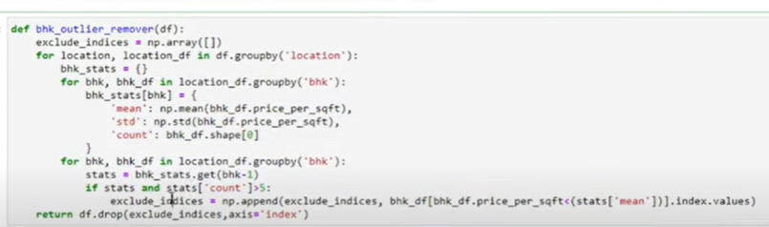

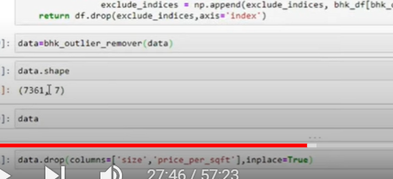

**Email Spam Classifier | SMS Spam Classifier | End to End Project | Heroku Deployment**

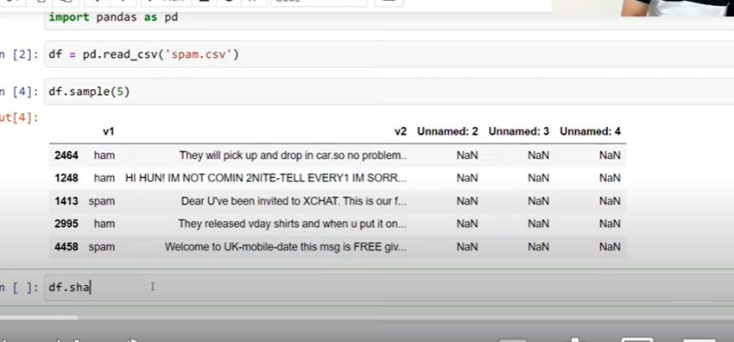

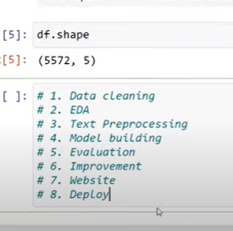

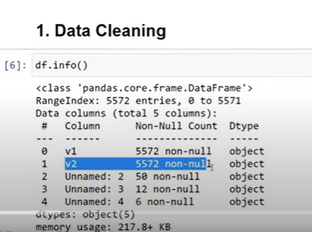

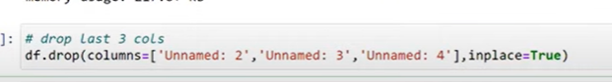

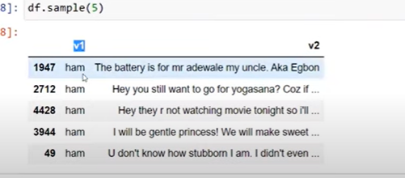

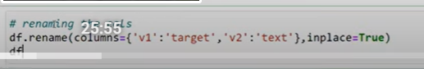

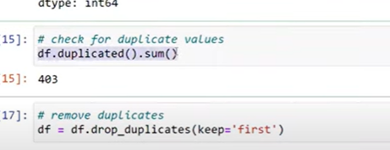

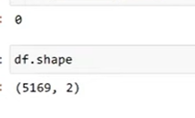

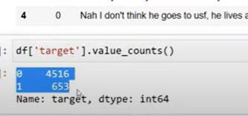

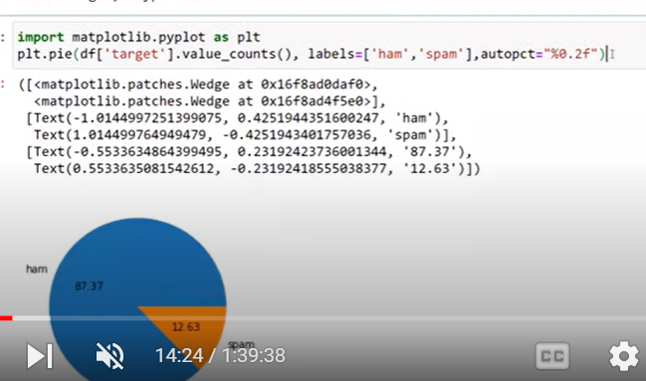

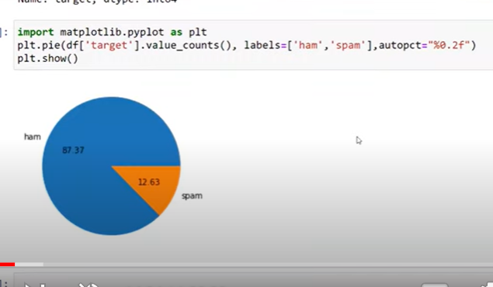

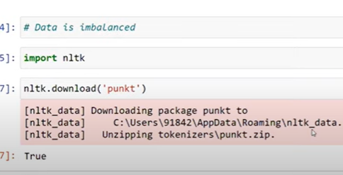

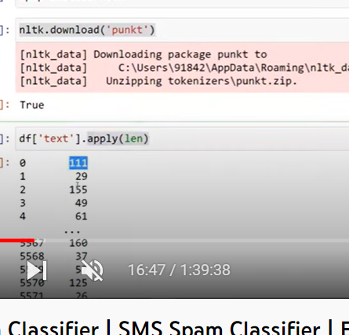

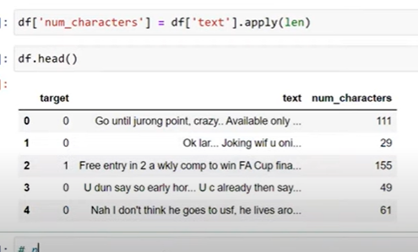

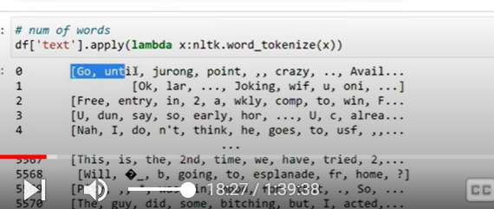

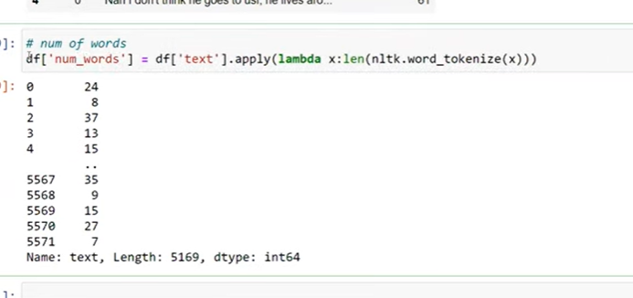



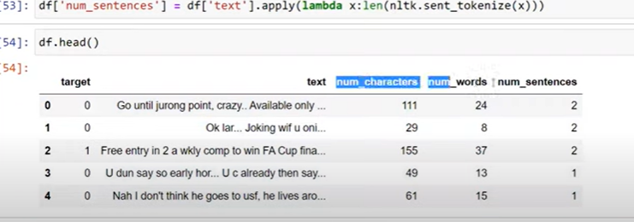

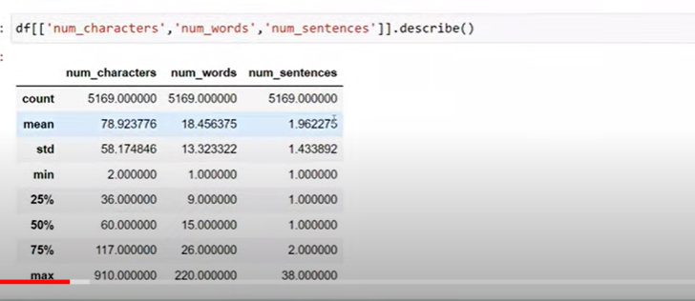

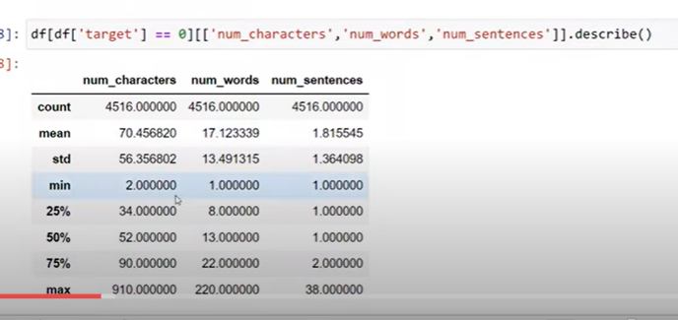

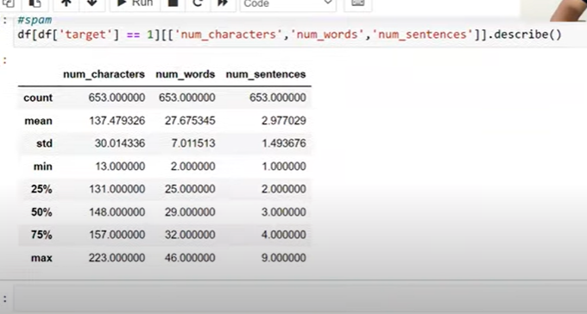

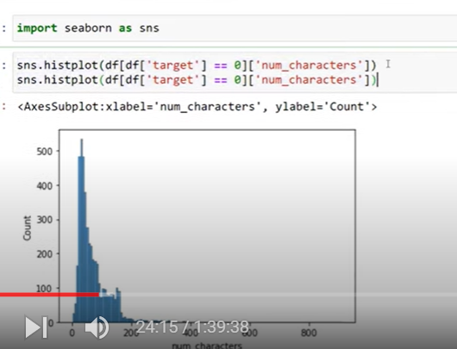

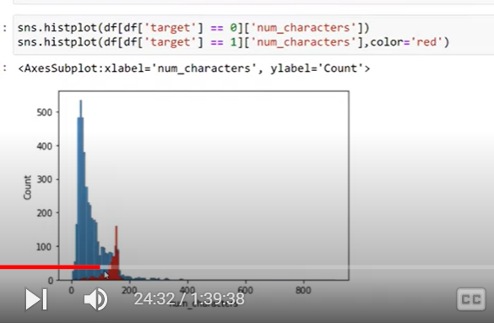

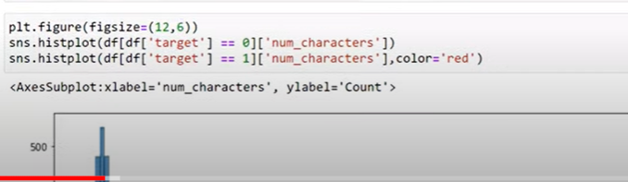

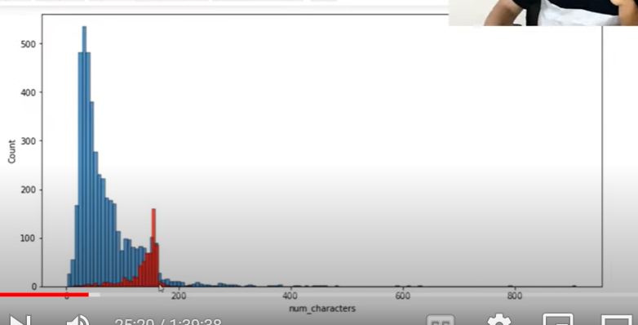

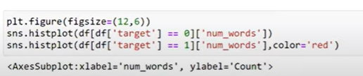

Similar histogram

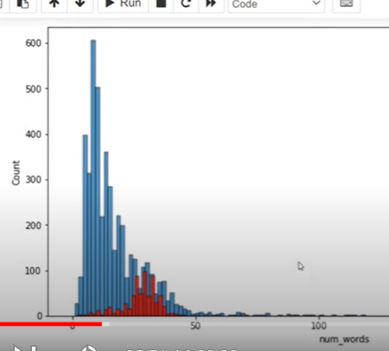

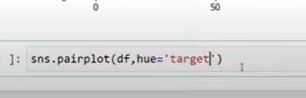

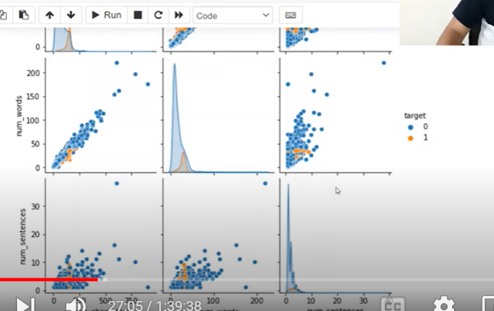

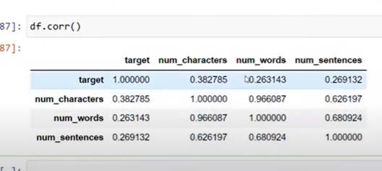

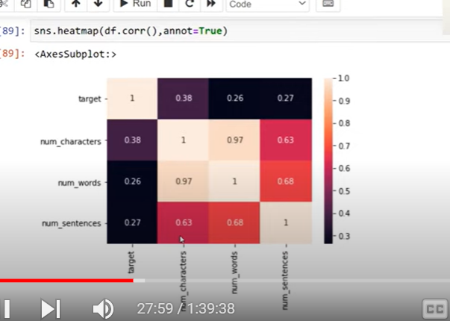

More character- high tendency to become spam